mllmml

|  |  |  |  |  |  |  |  |  |
| --- | --- | --- | --- | --- | --- | --- | --- | --- |
|  | | | | | | | | |
|  | | Project Report | | | | |  | |
|  |  | | | | | | |  |
|  | | | |  |  | | | |
|  | | | |  |  | | | |
|  | | | |  |  | | | |
|  | | |  | | |  | | |

|  |  |  |  |  |  |  |  |  |
| --- | --- | --- | --- | --- | --- | --- | --- | --- |
|  |  | | |  |  | | |  |
|  | Working | | | | | | |  |
|  |  | | |  |  | | |  |
|  |  | |  | | |  | |  |
|  |  |  | The Database when accessed redirects the user straight to the login page. Here, if the user chooses to login, they will be taken to their homepage after they provide a valid username and password. If they choose to sign-up, they will be redirected to another page where they will have to provide relevant information about themselves and their workout requirements. After their signup is complete, they will be redirected to their homepage and they will be provided with information about their profile and their weekly and daily requirements. | | |  |  |  |
|  | | | | |
|  |  |  |  |
|  |  |



|  |  |  |  |  |  |  |
| --- | --- | --- | --- | --- | --- | --- |
|  | |  |  |  |  | |
|  | | THE PROCESS | | |  | |
|  | |  |  |  |  | |
|  | Tables and ERD: The database is formed from four tables which track the information for each user. The main table is the “Member” table which contains the basic information of a user. The “workout plan” and “nutrition intake” tables track the workout details and nutrition details of the user respectively. And finally, the “log” table tracks the activities of a user. The ERD of this Database is given below: | | | | |  |

|  |  |  |  |  |  |  |
| --- | --- | --- | --- | --- | --- | --- |
|  | Front-end and Back-end: On the front-end, html is used to display the pages and take input from user. PHP is then used to process the entered data. This data is then stored through SQLPLUS in a “.sql” file.  C:\Users\ASD\Desktop\lg1.jpeg  C:\Users\ASD\Desktop\lg2.jpeg    C:\Users\ASD\Desktop\p2.jpeg | | | | |  |
|  | |  |  |  |  | |
|  |  | | | | |  |

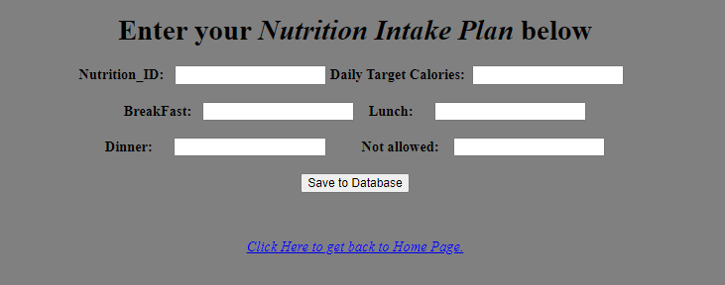

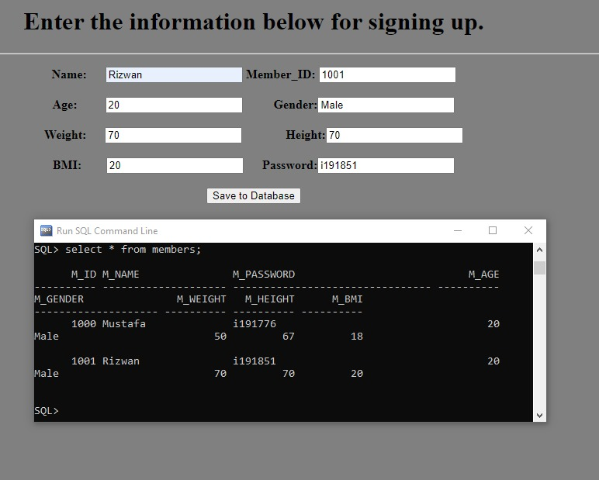

First the user sees the **Log In** page. If the user is already a registered member, he/she can log in and proceed with the website, otherwise, the user needs to register himself and is directed to the **Sign Up page.**

After this, the user is directed to the **Home Page** (screen shot pasted above). In this page, the user sees all the options to either enter his data or view all the options mentioned in the project statement where he is further taken to the respective pages.

The user can view a diet plan which is best suitable for him.

He can get information about different exercise types and set a target for himself.

After this, he can enter a workout and nutrition routine for himself and he can also track and log his current nutrition and work out progress in the **Log Page** from where he can get all the reports or insights on his progress which can help him get better.

Lastly, the user can log out of his account through the **Home page** so that another user can access the database.